12th Belgian Bubblecar rally 2025.
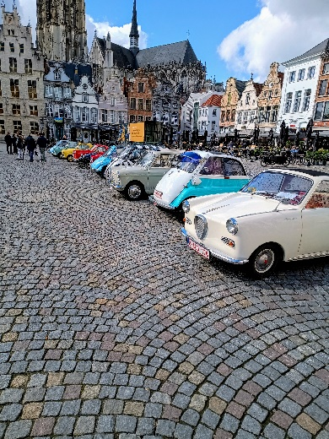
The Belgian bubblecar club will organize for the 12th time an international rally, this year it will be in the village of Wodecq (near the city of Ronse).
The rally starts on Friday the 25th of April at 12 o’clock and ends on Sunday the 27th of April 2025 approximately 3pm.
We will make a number of tours with some stops in between to visit interesting places.
On Friday and Saturday evening there is a cozy get-together with dinner for all participants.

Entrance fee for the rally-weekend is 150 € per person (this includes the roadbooks, Friday and Saturday evening dinner, Saturday and Sunday lunch.
Breakfast, drinks, accomodation and other related costs are excluded from this fee.
There is a possibility to order breakfast on Saturday- and/or Sundaymorning
at 9 euros per person per day.
In case you would like to do so, please place your order on the registration form.
There are a number of rooms available for booking by March 15 at the latest.
Rooms with a sink available at 80 euros per night and rooms with bath or shower at 100 euros per night.
For those who book a room in the notary’s house breakfast is included.

Camping pitches for mobile homes, caravans or tents are available at 15 euros per person per day.
If you whish to book a room or camping pitch, please request it by email to Patrickvanmol@skynet.be before 15/03/2025
All cars must be insured and road legal.
Please send your subscribed registration form by mail to : patrickvanmol@skynet.be or Belgianbubblecarrally@gmail.com
Subscription ends the 15th of March 2025. The number of participants is limited for safety reasons.
Only upon receipt of the entrance fee (15/03/2025 at the latest), payable by bank transfer to account number IBAN BE18 3631 4934 3765 BIC BBRUBEBB on name of Dwergautoclub België (DACB), your participation to the rally will be registered.
Scooters build in or before 1970 are also welcome to participate.
For more details about the rally :
Patrick Mobile : +32.(0)475.46.12.29 or email patrickvanmol@skynet.be
Address of the event :
La divine providence
Vieux Moulin 8
B-7890 Wodecq
We hope to welcome you in Wodecq.
Best regards,
The DACB team

